MIGRATE DOMAIN & DNS TO ROUTE53 AWS WITHOUT DOWNTIME

|  |  |  |
| --- | --- | --- |
|  |  |  |

In this article we will understand how to migrate domain, including DNS, without any downtime to Amazon Route 53.

Although, zero downtime is never guaranteed with this kind of process. However, the below process will minimize your risk.

Here are the steps you would need to take inorder to Migrate Domain & DNS to Route53: –

**MIGRATE DNS FIRST:**

**Step 1:** In Route 53, create the hosted zone for the domain

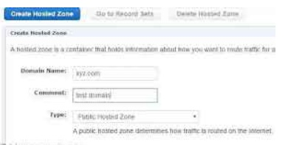

**Step 2:** Create the appropriate records within the hosted zone

**This step is every important**, reason, you will be replicating same environment as on registrar’s end. Meaning you will need

to migrate all the DNS entries( A, MX, CNAME and TXT) first to AWS Route53 hosted zone. I would recommend to create exact

same records you have in your registerar’s/hosting provider’s account, also I strongly recommend using **zone file** to export

all the DNS records to Route53 to avoid any human errors.

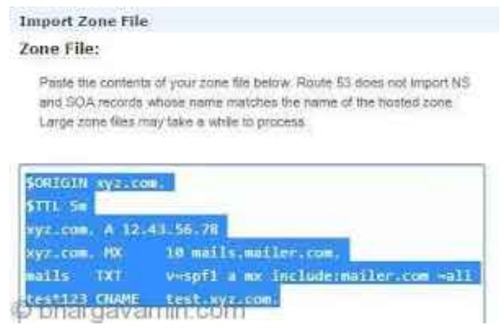

**THIS IS HOW CONTENT IN A ZONE FILE WILL LOOK LIKE**

Inorder to make sure the emails are not disturbed I would all recommend to **decrease the TTL** **period**for the **MX records**,

send update to the bulk email provider about the changes in advance, send them the new NS records generated by Amazon

Route53.

**Step 3:** Update your **DNS name servers** **and SOA records** with your current registrar to the new ones from the hosted zone you have just created

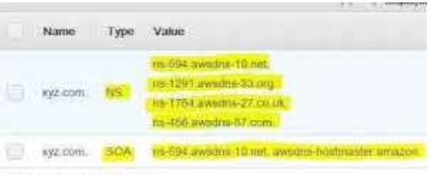

**ONLY UPDATE NS AND SOA RECORDS ONCE YOU HAVE TRANSFERED ALL THE DOMAIN (A, MX, CNAME, TXT) ENTRIES FROM REGISTRARS END TO**

**AWS ROUTE53.**

**For eg:** If you have a bigrock account then you’ll need to login and change the nameserver and SOA records to the one which AWS route53 provides.

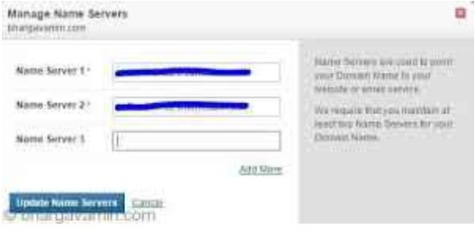

In Route53, you can find nameserver after you create a hosted zone (nameservers are not same for every hosted zone)

**Step 4:** Wait some time for any caching to expire (a day or two should be sufficient, but it depends on TTLs)

**Note**:You can change TTLs inorder to decrease to 599 seconds inorder to make sure the changes take effect in 10mins. You can use links like [toolbox.googleapps.com/apps/dig](http://googleweblight.com/i?u=http://toolbox.googleapps.com/apps/dig&hl=en-IN&tg=179&tk=10302917122411572686&geid=1021) to continuosly monitor the changes on your nameservers TTL.

**THEN TRANSFER YOUR DOMAIN:**

**Step 5:** Once you have done this, you can start the domain transfer to Route 53

The lasting you have to do now is to replace the NS and SOA record on your registrar’s/hosting account, Once you have done that you will need to wait until the changes are propogated.

You can check the same through this website : https://dnschecker.org/. You will see the changes around the globe taking effect one by one.

That’s it! You have successfully without any downtime have Migrated domains and DNS to Amazon Route53.